UNIVERSITY OF ENGINEERING AND TECHNOLOGY MARDAN


Data Mining lab: 06
Muhammad Ismail
23MDBCS415
Department: CS (Data Science)
6th Semester

Upload Dataset
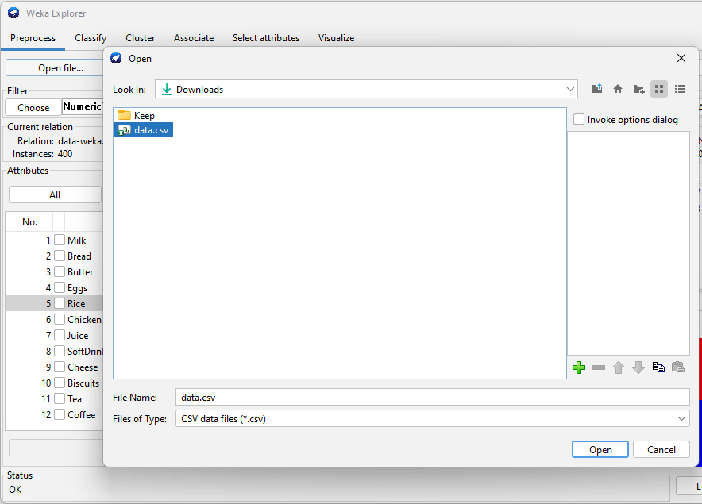
Filter numerictoNomial
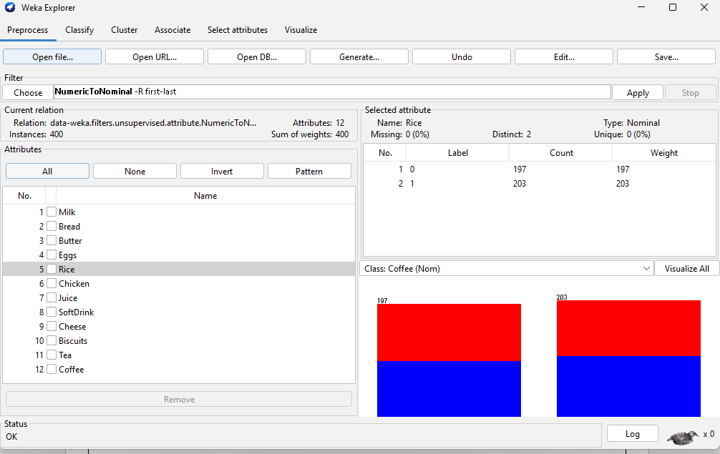
Short Explanation
This dataset contains 400 instances and 12 attributes representing items purchased in a retail store. Each attribute is nominal, indicating whether an item was purchased or not. The dataset is suitable for the Apriori algorithm because it represents transactional data, which helps discover associations between items frequently bought together.
Aprior Algorithm
Parameter Value
lowerBoundMinSupport 0.1
minMetric (confidence) 0.6
numRules 15
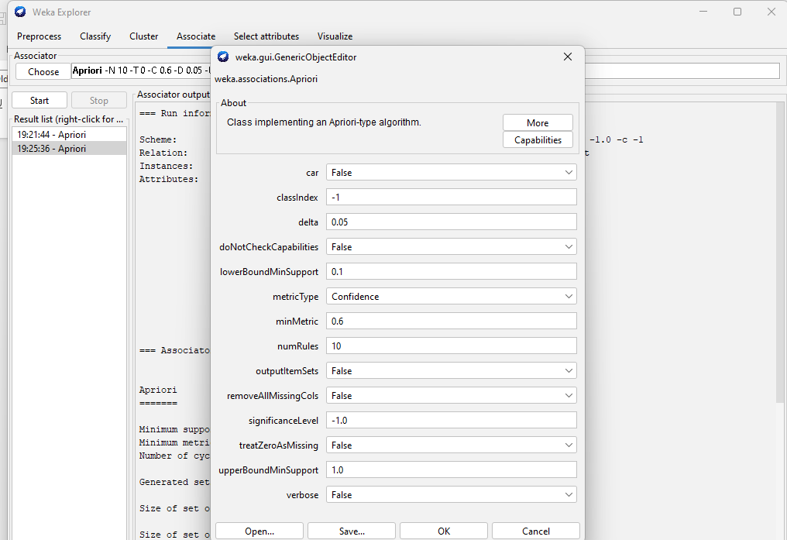
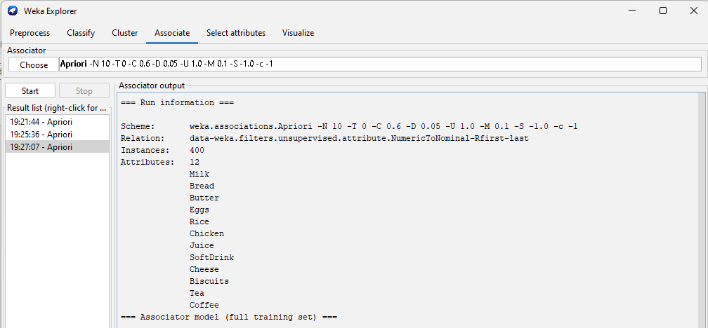
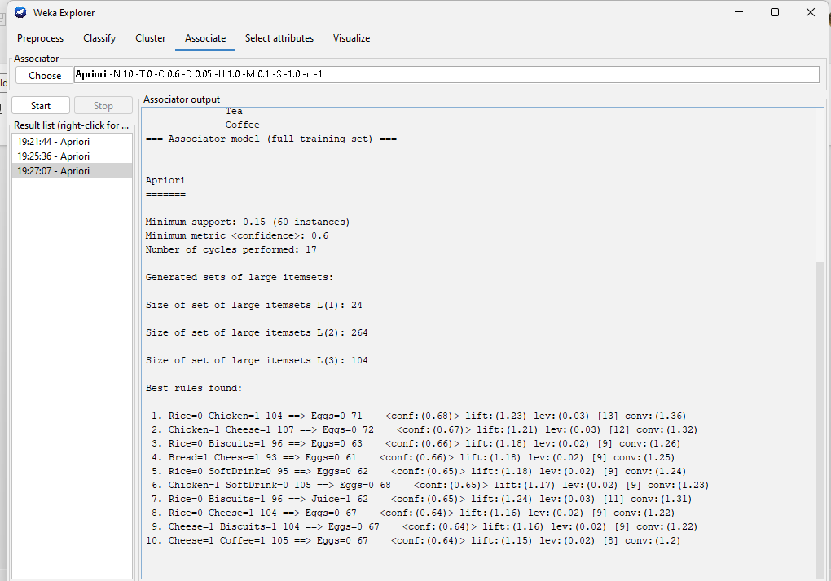

Top 3 Rule:
- Rice=0 Chicken=1 104 ==> Eggs=0 71 <conf:(0.68)> lift:(1.23) lev:(0.03) [13] conv:(1.36)
Meaning:
Customers who buy chicken but do not buy rice usually do not buy eggs.
Business Interpretation:
This suggests that customers purchasing chicken alone are less likely to purchase eggs. The store may focus on promoting eggs with chicken bundles to increase egg sales.

- Chicken=1 Cheese=1 107 ==> Eggs=0 72 <conf:(0.67)> lift:(1.21) lev:(0.03) [12] conv:(1.32)
Meaning:
Customers who buy chicken and cheese together often do not buy eggs.
Business Interpretation:
This indicates that eggs are not commonly purchased with chicken and cheese combinations. The store could introduce discount offers on eggs when customers buy chicken and cheese to encourage additional purchases.
- Rice=0 Biscuits=1 96 ==> Eggs=0 63 <conf:(0.66)> lift:(1.18) lev:(0.02) [9] conv:(1.26)
Meaning:
Customers who buy biscuits but do not buy rice are also less likely to buy eggs.
Business Interpretation:
This suggests that biscuits are typically purchased separately from eggs. Retailers may place eggs near biscuits or create combo deals to increase cross-selling.
Experiment A:
Support = 0.2
Confidence = 0.7
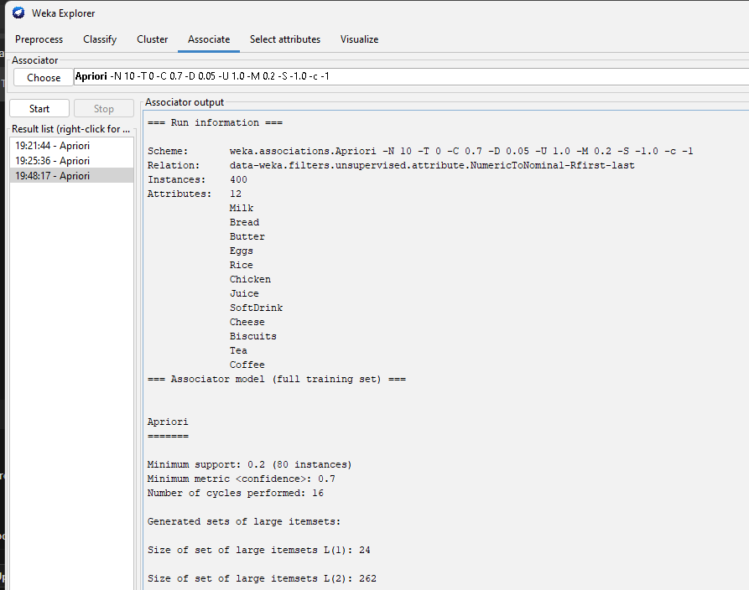
Experiment B:
Support = 0.05
Confidence = 0.5
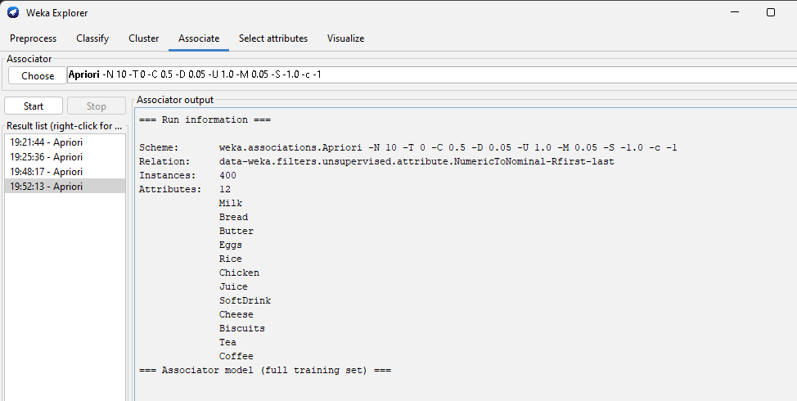
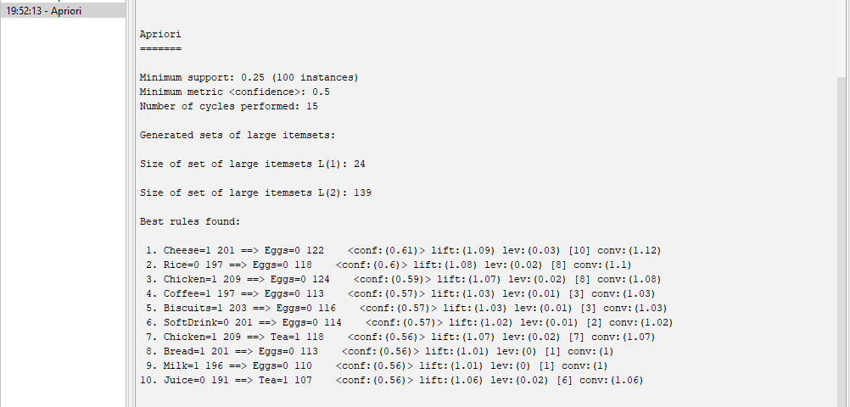

Parameter Tuning Comparison
Observation | Experiment A | Experiment B
Number of Rules | 3 | 10
Strongest Rule | Rice=0 & Chicken=1 → Eggs=0 | Cheese=1 → Eggs=0
Lift Value | 1.23 | 1.09

1. What happens when support decreases?
When support decreases, more item combinations are considered frequent, so more association rules are generated.

2. Why do rules increase?
Rules increase because lower support allows rare itemsets to be included, which produces a larger number of rules.

3. Which experiment gives stronger rules?
Experiment A gives stronger rules because it uses higher support and higher confidence, which results in more reliable associations.

